WORK SHEET - 2
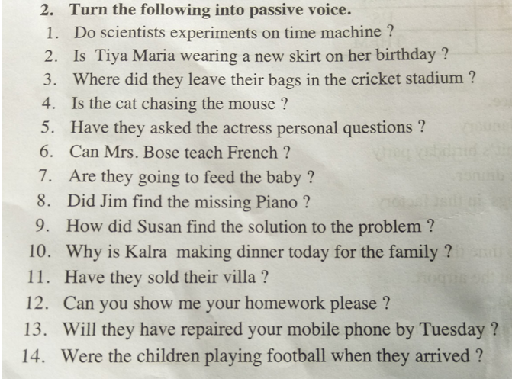
1. Is time machine experimented by scientists?
2. Is a new skirt being worn by Tiya Maria on her birthday?
3. Where were their bags been left by them in the cricket stadium?
4. Is the mouse being chased by the cat?
5. Is the actress been asked personal questions by them?
6. Can French be taught by Mrs. Bose.
7. Is the baby going to be fed by them?
8. Is the missing piano been found by Jim?
9. How the solutions to the problem been found by Susan?
10. Why dinner is made today by the Kalra family.
11. Is their Villa been sold by them?
12. Can your homework been shown to me by you please?
13. Will your mobile phone be repaired by them by Tuesday?
14. Is the football being played by the children when they arrived?

